BAPTISM FOR YOUR CHILD

A new child introduces you to all sorts of feelings. A baby can make you feel privileged excited, blessed exhausted, overwhelmed bewildered and scared – sometimes all at once!.

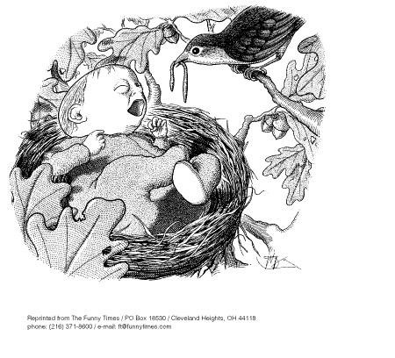
Where on that list would you put your own emotions right now? It took 9 months of preparation just to have this child and the task of caring for it has only just begun.

Many parents see baptism as something they want for their child quite early in life.

Your feelings about baptism, and your reasons for wanting it, are personal.

They can range anywhere from…..
“We don’t really know why; the in-laws insisted” to
“We want faith in Jesus to be as much a part of our child’s life as it is for us.”

Where on the range of possibilities would you put your own thoughts about wanting a baptism?
ONE THING’S FOR SURE;
Jesus welcomed small children unconditionally
– and they were happy to come to him. Here’s the story…

“People were bringing little children to Jesus to have him touch them, but the disciples rebuked them.
When Jesus saw this, he was indignant.
He said to them, "Let the little children come to me, and do not hinder them, for the kingdom of God belongs to such as these.
I tell you the truth, anyone who doesn’t receive the kingdom of God like a little child will never enter it."
And he took the children in his arms, put his hands on them and blessed them.”
Mark 10: 13-16

If you’re new to babies, you may not have noticed:
These were small children. Small enough still to be carried. Just the age to hide their face in Mum’s shoulder and howl if a bunch of strange men spoke roughly, and told them to go away. Yet when Jesus called the children to him, they came. What’s more they felt comfortable when Jesus took them from their mother’s arms.

If you’d been in that crowd, how would you feel about being told off for bringing your baby along?
What would your thoughts be about the disciples?
What would you ask from Jesus, for your child?
(The answer to that last question is also the reason you want your child baptized.)

Baptism is about wanting the best for your child, and about wanting to connect them with God.

MORE THAN JUST A BLESSING

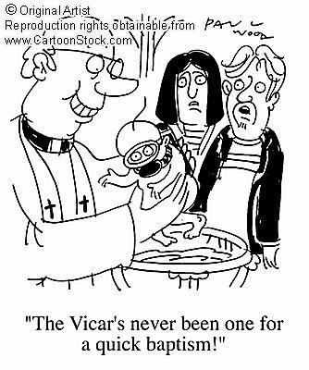
Baptism is more than a welcome ceremony, more than a naming ceremony, and more than a blessing ceremony.

From day one, baptism has been the ‘joining and belonging ceremony” for people who wanted to join the
Christian faith and the church

Some churches take baptism so seriously, they only baptize those who are old enough to ask for themselves.

The Uniting Church baptizes babies and children, because we recognize that God welcomes everyone on the same term as he does babies; just because God loves us to bits, even when we can’t do anything to qualify, or help ourselves.

BAPTISM IS ABOUT BELONGING
There’s no real point in joining a Leagues Club if you don’t like footy, and there’s no point in asking baptism for your child, if you don’t want the Christian Faith to be a key part of their life, and want them to grow up in the Christian faith.
If baptism is not really what you’re looking for, there are other options. You may, for instance, prefer to have a Service of Thanksgiving and Blessing.

JOINING AND BELONGING TO WHAT? SOME FAQs WHY NAME THE CHILD?
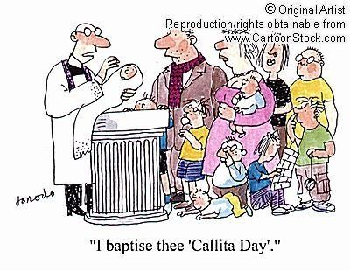
Your name is a symbol of who you truly are. Naming a child in baptism is a way to symbolize the fact that our true identity is given to us by God.

WHY THE “FATHER,
SON AND HOLY SPIRIT”?
From day one, people who asked for baptism were
wanting to connect and identify with Jesus, and what he’s done for us. Jesus told his followers to baptize “in the name of the Father, Son and Holy Spirit”, so we’d remember those three always go together, and they’re all part of God.

WHY THE WATER?
What does water suggest to you? (drinking washing, drowning, the Holy
Spirit? There is no single right answer)
Here’s what Paul had to say about baptism in Romans 6: 3-4
“Don't you know that all of us who were baptized into Christ Jesus were baptized into his death? We were buried with him (through baptism) into death so that, just as Christ was raised from the dead through the glory of the Father, we too may live a new life. “

WHAT DOES DEATH AND BURIAL, AND RISING FROM THE DEAD HAVE TO DO WITH LITTLE BABIES, JUST STARTING OUT WITH THEIR LIFE?
Heady stuff. Remember Baptism in Paul’s day was a service for adults. The
point he makes is that is, that baptism, which felt a bit like dying, symbolized not the end but the beginning of life, forever, in God.

GOD WHO?
There’s a story of a little girl who told her mother she was going to draw God. “But no-one’s ever seen God,” protested her mother, “We don’t know what he looks like.” “Well, you will when I’ve finished,” declared her daughter. You don’t have to draw it – but what does your “picture of God” contain?

HERE’S A TIP: Jesus told one of his friends, “If you’ve seen me, you’ve seen the Father.” In other words, If you want to know what God’s like, God is like Jesus. We saw before, from Mark’s story, how Jesus feels about your child, (and about you). God feels the same way.

DO WE HAVE TO BELIEVE A WHOLE LOT OF STUFF?
Err, no, actually. There’s no party line on belief. You will be asked, as part of
the ceremony. “Do you believe that in Jesus Christ, God offers us forgiveness of sins and a new life in relationship with Him?” because essentially, there’s not much point in asking for Christian Baptism if you don’t.

DO WE HAVE TO JOIN THIS CHURCH?
No. Most mainline denominations recognize that baptism in any Christian Church is valid for their church.

DO WE HAVE TO COME TO CHURCH?
Again, no. (Not that we don’t think, it’s a really good idea) You will be asked, as part of the ceremony:

- Will you provide for your child a Christian home of love and trust?

- Will you set before your child the example of a Christian life, and will you pray that he/she will personally become a follower of Jesus Christ?

- Will you encourage your child to grow within the fellowship of the Church, so that he/she may learn the truth of the Christian faith and come to faith in Christ?

These questions are important and if you don’t want your child to be part of the church, there’s not much point in having a Christian Baptism.

